FEDERAL STATE AUTONOMOUS EDUCATIONAL INSTITUTION

OF HIGHER EDUCATION

ITMO UNIVERSITY

Report

on the practical task No. 4

“Algorithms for unconstrained nonlinear optimization. Stochastic and

metaheuristic algorithms”

Performed by

*Vdovkina Sophia*

*Syrchenko Arina*

*Academic group: J4133c*

Accepted by

Dr Petr Chunaev

St. Petersburg

2022

**Goal**

The use of stochastic and metaheuristic algorithms (Simulated Annealing, Differential Evolution, Particle Swarm Optimization) in the tasks of unconstrained nonlinear optimization and the experimental comparison of them with Nelder-Mead and Levenberg-Marquardt algorithms.

**Formulation of the problem**

1. Generate the noisy data $(x_{k},y_{k})$, where $k=0,…,1000$, according to the rule:

$$y_{k}=\left\{\begin{aligned}-100+δ_{k},f\left(x_{k}\right)←100, \\ f\left(x_{k}\right)+δ_{k},-100≤f\left(x_{k}\right)≤100, \\ 100+δ_{k},f\left(x_{k}\right)>100,\end{aligned}\right.x_{k}=\frac{3k}{1000},$$

$$f(x)=\frac{1}{x^{2}-3x+2},$$

where $δ_{k}∈N(0,1)$ are values of a random variable with standard normal distribution. Approximate the data by the rational function

$$F(x,a,b,c,d)=\frac{ax+b}{x^{2}+cx+d}$$

by means of least squares through the numerical minimization of the following function:

$$D(a,b,c,d)=\sum_{k=0}^{100}{{(F(x_{k},a,b,c,d)-y_{k})}^{2}}.$$

To solve the minimization problem, use Nelder-Mead algorithm, ﻿Levenberg-Marquardt algorithm and at least two of the methods among Simulated Annealing, Differential Evolution and Particle Swarm Optimization. If necessary, set the initial approximations and other parameters of the methods. Use $ε=0.001$ as the precision; at most 1000 iterations are allowed. Visualize the data and the approximants obtained in a single plot. Analyze and compare the results obtained (in terms of number of iterations, precision, number of function evaluations, etc.).

1. Choose at least 15 cities in the world having land transport connections between them. Calculate the distance matrix for them and then apply the Simulated Annealing method to solve the corresponding Travelling Salesman Problem. Visualize the results at the first and the last iteration. If necessary, use the city dataset from https://people.sc.fsu.edu/~jburkardt/datasets/cities/cities.html

**Brief theoretical part**

Stochastic methods use randomization to help finding the optimum. Such that, randomness can help escape local optimum and increase the chances of finding a global optimum. Stochastic methods also do not guarantee an exact solution and convergence, but they can find a solution in a reasonable time.

Metaheuristic algorithms are a class of stochastic algorithms using a combination of randomization and local search. They are often inspired by nature or biological systems.

*Simulated annealing*

Simulated annealing is a probabilistic technique for approximating the global optimum of a given function, it was inspired by metallurgy, where it is a technique of controlled heating and cooling of a material. The internal processes of a metal are simulated by some mathematical system ad the goal is to bring the system, from an arbitrary initial state, to a state with the minimum possible energy. Temperature is used to control the degree of stochasticity during the randomized search. The temperature starts high, so that algorithm makes big steps around the search space until it finds the local minimum. Then the temperature slowly decreases, reducing the stochasticity and forcing the search to converge to a minimum. But before converging to some local minimum algorithm with some probability decides whether jump to another state or stay where it is. Simulated annealing is can used on functions with a lot of local minimums due to its ability to escape local minima.

*Differential evolution*

Differential evolution is a population-based metaheuristic search algorithm that optimizes a problem by iteratively improving a candidate solution based on an evolutionary process. It improves each individual in the population by combining it with other individuals and then it keeps the candidate solution with the best score or fits better for the particular problem. By having a large number of individuals distributed throughout the design space algorithm avoids becoming stuck in a local minimum.

*Particle swarm optimization*

Particle swarm optimization solves a problem by having a population of candidate solutions (dubbed particles) and moving these particles around in the search-space. Particle swarm optimization introduces momentum to accelerate convergence towards minimum. Each particle moves with respect to its local best-known position, but it also guided towards the best-known position in the search-space, that is updated while better positions are found by other particles. This is expected to move the swarm towards the best solutions.

*Travelling Salesman Problem*: Given a set of cities and distance between every pair of cities, the problem is to find the shortest possible route that visits every city exactly once and returns to the starting point

**Results**

1. In order to solve the minimization problem, Nedler-Mead algorithm, Levenberg-Marquardt algorithm, Simulated Annealing and Differential Evolution were used.

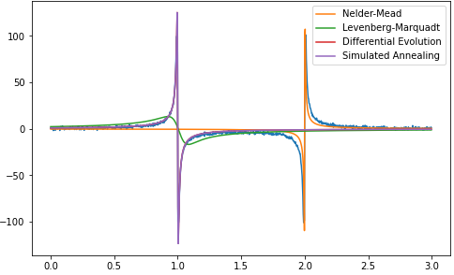

Picture 1 – results obtained by the Nelder-Mead algorithm, Levenberg-Marquardt algorithm, Differential Evolution and Simulated Annealing

As shown on picture 1, all methods converged to extremely close results. Table 1 shows detailed results for the obtained values, number of iterations and function evaluations.

Table 1 – results obtained by the algorithms

|  |  |  |  |
| --- | --- | --- | --- |
| Method | Obtained function value | Iterations | Function calculations |
| Nelder-Mead | 159387 | 381 | 654 |
| Levenberg-Marquardt | 121242 | - | 141 |
| Simulated Annealing | 136058 | 1000 | 8931 |
| Differential Evolution | 136067 | 139 | 8460 |

All minimization methods gave a bit different value of the minimization function. As expected, stochastic methods required more iterations and calculations of functions to find a solution with a given accuracy, because they based on randomness, so they are not proved to converge always. The Levenberg-Marquardt algorithm required the least number of function calculations, so it can be named as the best algorithm.

1. For the experiment data for 22 cities in West Germany was considered then the annealing simulation method was applied to solve the Travelling Salesman Problem.

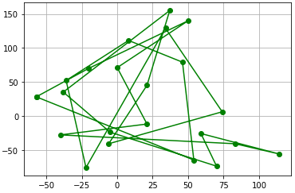

Picture 1 – the initial state

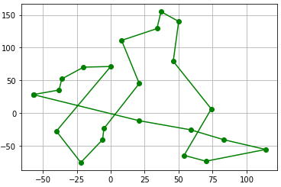

Picture 2 – solved problem

The initial path was 2135 cu long, while the best-found path turned out to be 983 cu long.

**Conclusion**

As a result of the work, stochastic methods were used to minimize the function. The performance of two meta-heuristic methods – differential evolution and simulated annealing were analyzed and compared with direct Nelder-Mead algorithm and gradient-based Levenberg-Marquardt algorithm. Among the stochastic methods considered, the differential evolution method turned out to be more effective, however, when compared with other methods, the Levenberg-Marquardt algorithm turned out to be more effective.

Gradient-based methods such as Levenberg-Marqard however may show poor results because it is not well suited for the problems with non-continuous search space with several optimum points.

The simulated annealing algorithm was applied to solve the Travelling Salesman Problem for 15 cities.

**Appendix**

Source code is available on <https://github.com/sophia-vdovkina/Analysis-and-development-of-algorithms/blob/main/Task%204/Task4.ipynb> for the first part

<https://github.com/sophia-vdovkina/Analysis-and-development-of-algorithms/blob/main/Task%204/Travelman%20problem.ipynb> for second part